**SQL ASSIGNMENT – 2**

**1) Write an SQL query to print the first three characters of  FIRST_NAME from Worker table.**

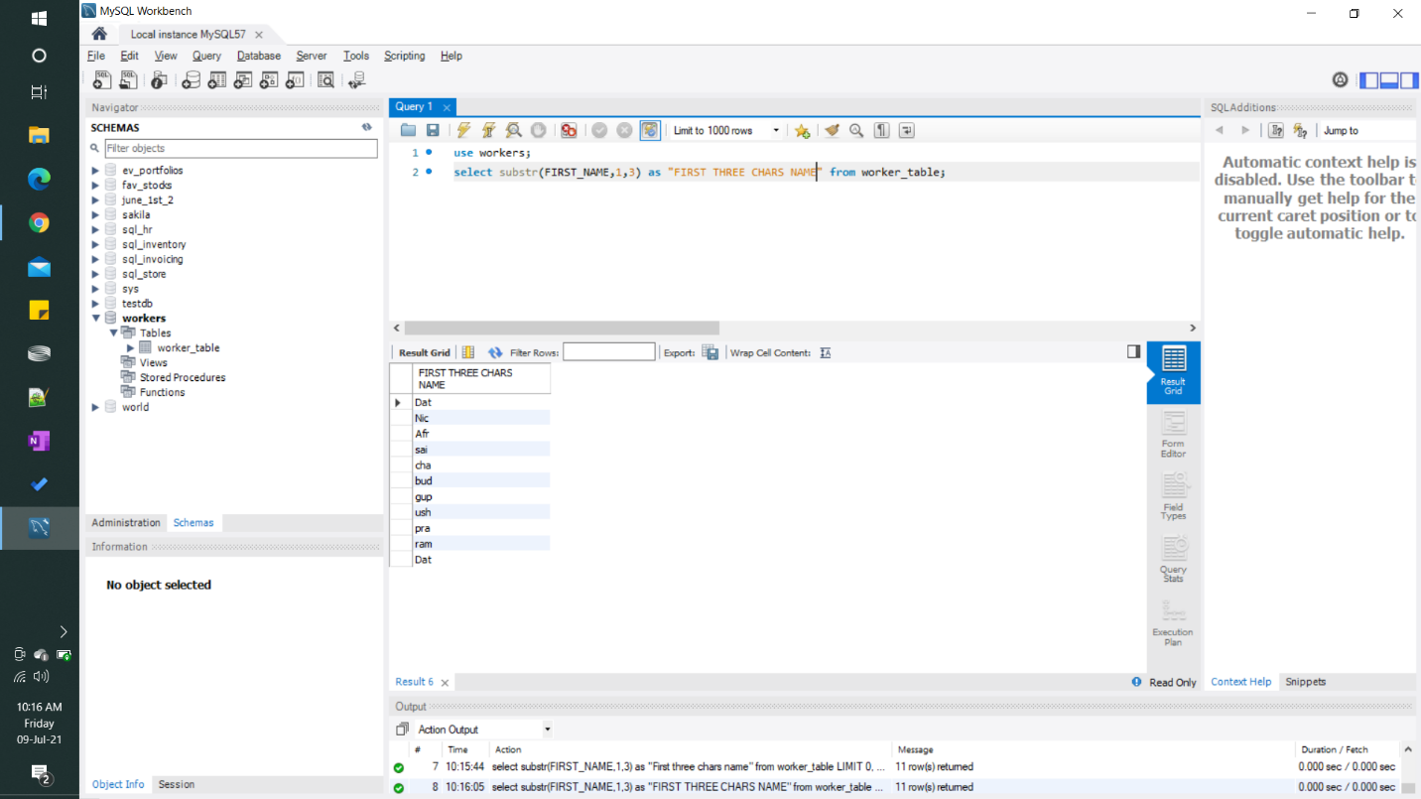

**2) Write an SQL query to find the position of the alphabet (‘a’) in the first name column ‘Amitabh’ from Worker table.**

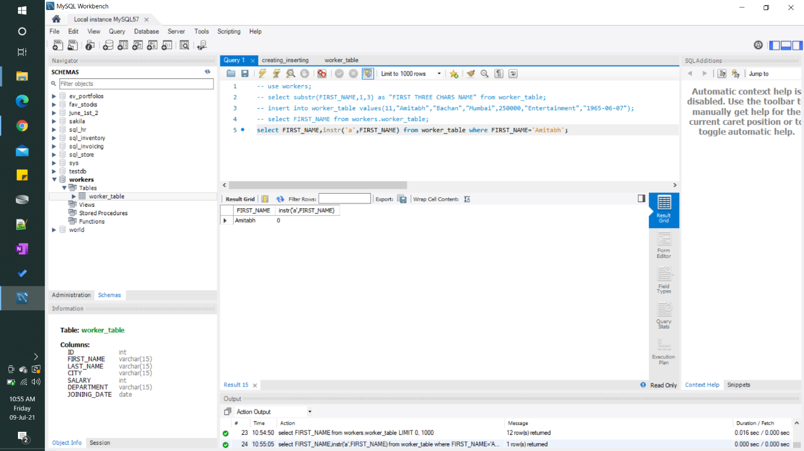

**3) Write an SQL query to print the name of employees having the highest salary in each department.**

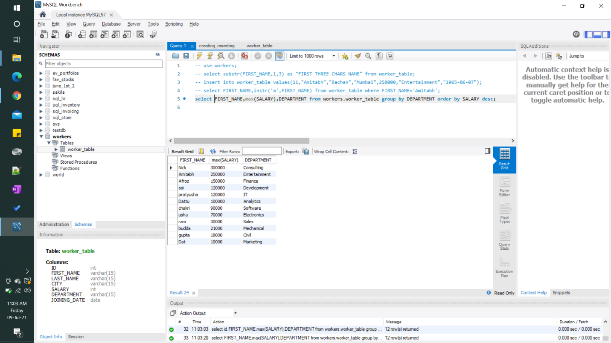

**SCHEMA IN THE WORKER TABLE**

